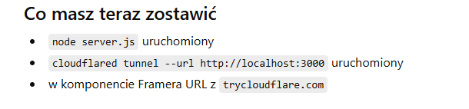

node server.js
cloudflared tunnel --url http://localhost:3000

